Home Inspection Report

  Inspector Information
  Name: | John Smith
  Company: | Smith's Home Inspections
  Address: | 1234 Maple Avenue
  City: | Rosemont
  State/Province: | IL
  Zip/Postal: | 60018
  Phone: | 847-555-2922
  Cell: | 847-555-1017
  Fax: | 847-555-2921
  License #: | 450.1001001
  E-mail: | js@s-inspect-co.com
  Web: | http://s-inspect-co.com
  Client Information
  Name: | John and Teresa Reynolds
  Address: | 1234 Sugar Court
  City: | Mount Prospect
  State/Province: | IL
  Zip/Postal: | 60056
  Phone: | 627-555-2822
  Cell: | 627-555-3488
  E-mail: | jtreynolds2373@hotmail.com
  Date of Inspection: | October 10, 2006
  Time: | 2:30 P.M.
  Weather Conditions: | Fair, 70 degrees F.
  Attendance: | Buyer, Buyer's Agent
Property Address:
5678 Lemon Street
Mount Prospect, IL
60056
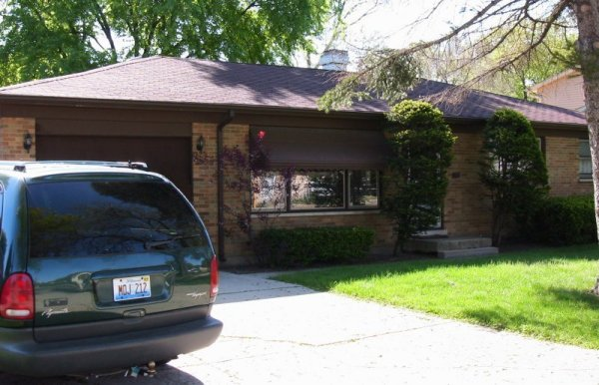

IMPORTANT INFORMATION
This report is solely for the benefit of the Client. Any person or party designated by the Client to receive information in this report shall be subject to the TERMS AND CONDITIONS contained herein. Such designation shall be provided in writing to the inspector.
Items in Need of Immediate Attention:
-- The deck is in very poor condition and will need to replaced.
-- Asphalt roof covering needs to be replaced soon and appears to have active leaks.
-- One of the wires shown in the photo has melted insulation which could indicate an over-fused circuit.
-- It appears that a roof leak is draining down the wall in the laundry room.
-- The wall was exposed behind the bathtub where the supply pipes appear to have a slow leak

REPORT SUMMARY
General Comments:
This inspection report identifies items in need of attention, maintenance, or repair, which is the primary function of a home inspection. Overall, it is the inspector's opinion that this is a quality-built dwelling that is in need of moderate repair to keep it in serviceable condition. Some additional maintenance items may be discovered in the course of repairs, upgrading, or when the home is vacant. We recommend that you obtain repair estimates from competent specialists as an aid in planning your future course of action.
The items listed in this report are marked as Satisfactory, In Need of Maintenance, Professional Consultation, or Not Satisfactory. The inspector has identified and described the home's major systems and components, and has listed problems found in readily accessible areas as explained in the pre-inspection agreement. You should refer to the pages in this report for information about a specific component or system. This summary is an overview, not an all-inclusive list of defects found in the dwelling. It is the client's responsibility to read the entire report and contact the inspector if you have any questions.
Site Grounds and Grading Summary:
Trees and Shrubs:
Shrubbery is contacting structure which can cause damage or retain water. (Refer to report section for details.)
Grading at House Wall:
Slope of grade away from structure is inadequate. The grade slopes toward structure. (Refer to report section for details.)
Steps to Building:
The stoop has settled near the house creating reverse drainage. The area is not properly flashed or caulked. Cracks in concrete or mortar are in need of repair. (Refer to report section for details.)
Deck:
Deck has deteriorated severely. Rail system is not securely attached. Consult a licensed contractor about the needed repairs. (Refer to report section for details.)
Retaining Walls:
The retaining wall at the back of the home has been damaged. (Refer to report section for details.)
Driveway:
There are some large cracks that are consistent with the age of the property, but they do not affect the functionality of the driveway. (Refer to report section for details.)
Eaves and Soffits:
Some of the soffit vents appear to be blocked or covered. (Refer to report section for details.)
Exterior and Structure Summary:
Windows:
Windows are not properly caulked and require minor repair. (Refer to report section for details.)
Gutters and Downspouts:
Downspout does not divert water away from foundation properly. There are downspouts that need to be extended. (Refer to report section for details.)
Chimney:
Rusting was observed on chimney cap. Chimney flashing is improperly installed. (Refer to report section for details.)
Gas Meter/Piping:
The gas meter is right next to the driveway where it could be damaged by a vehicle. (Refer to report section for details.)
Exterior Receptacles:
All exterior outlets should be GFI protected. All exterior outlets need weatherproof covers. (Refer to report section for details.)
Roofing Components Summary:
Roof Leaks:
There are some sunken areas where it is apparent that the shingles have failed and water is penetrating onto the sheathing. (Refer to report section for details.)
Flashing:
Leaking observed at the chimney flue. (Refer to report section for details.)
Gutters and Downspouts:
There are down spouts that need to be extended. Damage or failure was observed. (Refer to report section for details.)
Plumbing Components Summary:
Waste:
Cast iron part of system appears to have a small amount of seepage near clean-out. (Refer to report section for details.)
Pipes:
Corrosion, slow seeping water leaks found on galvanized piping. (Refer to report section for details.)
Fixtures:
Corrosion and indications of slow leaks were detected. (Refer to report section for details.)
Electrical Components Summary:
Service Entrance Cable:
It appears that the roof anchor for this overhead service has been pulling away from the roof sheathing. (Refer to report section for details.)
Main Panel:
One of the wires has melted insulation which could indicate an over-fused circuit. This could represent a fire hazard and should be examined by an licensed electrician. (Refer to report section for details.)
Outlets, Fixtures, and Switches:
No power was observed at the receptacle outlet in family room. Outlet covers are broken. Reverse polarity of receptacle outlets was observed in the den. Receptacle outlet spacing appears to be inadequate in some rooms. (Refer to report section for details.)
Smoke Detectors:
Smoke detectors are installed too far from bedrooms. (Refer to report section for details.)
Attic Summary:
Attic Ventilation:
Insulation is blocking eaves vents. (Refer to report section for details.)
Attic Insulation:
Insulation has no vapor barrier to prevent moisture condensation within insulation material. (Refer to report section for details.)
Attic Sheathing:
Dark areas indicative of water penetration on SE area of sheathing below area of suspected shingle failure. (Refer to report section for details.)
Ceiling Frame:
The roof leak has caused some limited damage to the ceiling frame. (Refer to report section for details.)
Attic Vent Pipes:
There are some apparent leaks at flashing points where an exhaust flue goes through the roof. The stains on the flue are indications of this leak. (Refer to report section for details.)
Attic Moisture:
Darkened areas where water is penetrating roof surface at failed shingles. (Refer to report section for details.)
Interior Summary:
Windows:
Window sashes do not operate properly in lower level bedroom. Window weather stripping is damaged or defective. Fire egress for the window is inadequate in NE bedroom. (Refer to report section for details.)
Stairs/Railings:
The handrail is loose. The handrail bracket is loose. This can constitute a safety hazard. (Refer to report section for details.)
Walls:
There is a crack in the kitchen wall near the ceiling which could indicate uneven settlement in one area of the house. (Refer to report section for details.)
Fireplace:
The flue is in apparent need of cleaning. Combustibles are too close to the fireplace opening. (Refer to report section for details.)
Den/Home Office
This converted room is not connected to the primary source of ventilation. (Refer to report section for details.)
Interior Door 4
The lower den door does not close properly. (Refer to report section for details.)
Bedroom 1
This northeast bedroom does not have an operable window. Legal bedrooms must have a method of egress.
Bathrooms Summary:
Bathtub in Bathroom 1:
Slow drainage was observed. Faucet handles are missing, broken or defective. The wall was exposed behind the bathtub where the supply pipes appear to have a slow leak. (Refer to report section for details.)
Sinks in Bathroom 1:
Water pressure appears low at this fixture. Corroded galvanized pipe beneath sink appears to be seeping and rust build-up inside the pipe could be occurring. (Refer to report section for details.)
Bathtub in Bathroom 2:
Rehabilitation of caulking is needed. (Refer to report section for details.)
Floor in Bathroom 2:
Tile is cracked near tub and needs to be repaired and re-grouted. (Refer to report section for details.)
Basement and Crawlspace Summary:
Basement Walls:
There are several thin cracks visible in the foundation less than a quarter inch wide which are typical of an older masonry foundation. (Refer to report section for details.)
Vapor Barrier:
The basement contains an additional gravel-covered crawlspace that needs to be covered completely by a vapor barrier. (Refer to report section for details.)
Sewage Ejector:
The sewage ejector pump was unplugged and may not function properly. (Refer to report section for details.)
Heating Components Summary:
Heating System in Heating System 1:
Furnace is not efficient and is nearing the end of its useful life. (Refer to report section for details.)
Unit Venting in Heating System 1:
Supply air is drawn from inside the house. (Refer to report section for details.)
Air Conditioning Summary:
AC Unit 1:
The insulation on the return line is missing, damaged, or defective decreasing efficiency. Clean leaves and debris away from outdoor condenser coil. (Refer to report section for details.)
Garage and Carport Summary:
Separation Wall:
Repair all breaches in common drywall. Floor penetrations are not properly fire stopped. Ceiling penetrations are not properly fire stopped. (Refer to report section for details.)
Receptacles:
Garage receptacles are not ground fault circuit interrupter type. (Refer to report section for details.)

Site Grounds & Grading

This inspection is not intended to address or include any geological conditions or site stability information. For information concerning these conditions, a geologist or soils engineer should be consulted. Any reference to grade is limited to only areas around the exterior of the exposed foundation or exterior walls. This inspection is visual in nature and does not attempt to determine drainage performance of the site or the condition of any underground piping, including municipal water and sewer service piping or septic systems. When decks and porches are built close to the ground where no viewing or access is possible, we cannot make accurate opinions. These areas as well as others that are too low to enter, or in some other manner not accessible, are excluded from the inspection and are not addressed in this report. We routinely recommend that inquiry be made with the seller about knowledge of conditions.
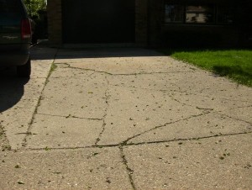
Driveway
Type: Concrete
Condition: Needs Maintenance
Problems:
-There are large cracks in the driveway.
Comments:
There are some large cracks that are consistent with the age of the property, but they do not affect the functionality of the driveway. These cracks should be monitored.
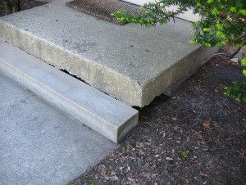
Steps To Building
Stair Type: Concrete
Landing: Concrete
Railing: No
Condition: Needs Maintenance
Problems:
-The steps are settling away from the house
Comments:
The stoop has settled near the house creating reverse drainage. We recommend railings on landing & stairs for safety. The area is not properly flashed or caulked. There is evidence of poor drainage. Cracks in concrete or mortar are in need of repair.
Sidewalks/Walkways
Type: Concrete
Condition: Satisfactory
Comments:
Some settlement was observed that is consistent with the age of the property and does not pose a serious problem in the opinion of this inspector.
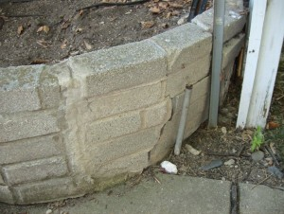
Retaining Walls
Type: Brick
Location: South wall
Condition: Needs Maintenance
Problems:
-The retaining wall shows signs of deterioration.
Comments:
The retaining wall at the back of the home has been damaged. The retaining wall is deteriorating. Cracks in the retaining wall could lead to further cracking and erosion.
Window Wells
Type: Metal
Condition: Satisfactory
General Grading/Drainage
Condition: Needs Maintenance
Problems:
-The ground slopes toward the house creating a flooding hazard.
-There are low-lying areas where water can pool.
Comments:
Suggest asking home owner about any yard flooding problems that occur during heavy rains. There are often simple solutions to prevent water from pooling on the property near the house.
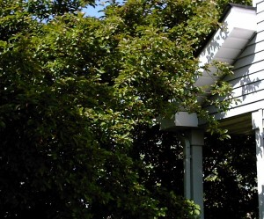
Trees & Shrubs
Condition: Needs Maintenance
Problems:
-There are trees growing within 6 feet of the house.
-There are tree branches rubbing against the house.
-There are trees growing too close to power lines.
-There are shrubs growing too close to the foundation.
Comments:
Keep tree branches trimmed away from the roof. Keep tree branches trimmed away from the siding. Shrubbery is contacting structure. Keep shrubs trimmed away from the siding. We suggest that broken tree limbs be removed.
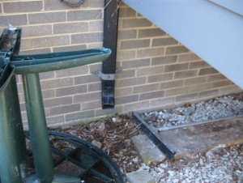
Grading At House Wall
Condition: Needs Maintenance
Problems:
-The ground slopes toward the house creating a flooding hazard.
-There are low-lying areas where water can pool.
*The grounds were not inspected for roof run-off.
Comments:
Slope of grade away from structure is inadequate. The grade slopes toward structure. Add fill near the house to slope away approximately 1" per ft. within 6 ft. Keep downspouts extended 5-6 ft. from the house.

Patio/Terrace
Condition: Satisfactory
Type: Concrete
Location: south
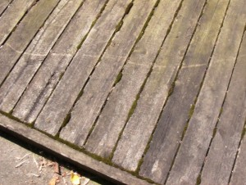
Deck/Porch
Condition: Needs Maintenance
Type: Wood
Construction: Nailed to House
Deck: On Grade
Railing: Yes
Problems:
-There is evidence of deterioration where the deck comes in contact with the ground.
-There is evidence of rot on the surfaces of untreated wood.
-There is cracking/deterioration on the deck floor or railings.
-There is separation or sagging due to deterioration.
-There is flashing missing between the deck and the house.
Comments:
Deck has deteriorated severely due to pour poor drainage which has caused water damage. Rail system is not securely attached. You should consult a licensed contractor about the needed repairs.
Out Buildings
Condition:
Out Building: None Observed
Fences
Condition: Needs Maintenance
Type: Wood
Problems:
-The fences/gates are rotting or deteriorating.
-The gates are sagging or falling off the hinges.
-There are untreated wooden fence posts buried directly in the ground.
Comments:
The fence is showing signs of deterioration/rot.

Exterior & Structure

Our inspection of the Exterior grounds includes the surface drainage, grading, some fencing, gates, sidewalks, patios, driveways, and retaining walls adjacent to the structure. The inspection of the exterior of the building includes the cladding, trim, eaves, fascias, decks, porches, downspouts, railings, doors, windows and flashings. Areas hidden from view by finished walls or stored items cannot be judged and are not a part of this inspection. Minor cracks are typical in many foundations and most do not represent a structural problem. If major cracks present along with rotation, we routinely recommend further evaluation be made by a qualified professional structural engineer. The grading of the soil should allow for surface and roof water to flow away from the foundation. All concrete slabs experience some degree of cracking due to shrinkage in the drying process or minor settlement. All items listed are inspected for their proper function, poor installation, excessive wear and general state of repair. Where deck carpeting, stacked firewood, excessive vegetation, soil and other coverings are installed over decking and patio surfaces, the materials or their nature of construction and condition of the underneath these coverings cannot be determined.
Building Information
Year Constructed: 1964
Type: Single
Wall Structure
Condition: Satisfactory
Type: Wood Frame
Comments:
This component is functioning properly.
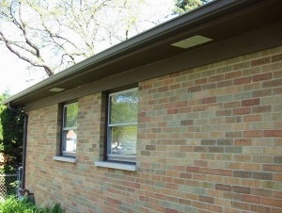
Wall Covering
Condition: Satisfactory
Type: Brick, Vinyl
Problems:
-There are no weep holes in the bottom of brick veneers.
Comments:
Recommend adding weep holes to the bottom course of bricks to allow possible trapped water to drain out from wall cavity.
Exterior Receptacles
Condition: Needs Maintenance
Type: Non-GFCI
Problems:
-There are exterior outlets being exposed to the weather without a weather plate.
Comments:
All exterior outlets should be GFI protected. All exterior outlets need weatherproof covers.
Gas Meter & Piping
Condition: Professional Consultation
Comments:
The gas meter is right next to the driveway where it could be damaged by a vehicle. A gas meter in such a location should be moved or protected against impact.
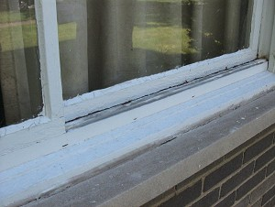
Exterior Windows
Condition: Needs Maintenance
Problems:
-There are gaps or openings around the window(s) that need to be caulked.
-There are cracked, broken, or missing windows.
Comments:
This component is in need of minor repair. Windows are not properly caulked. Over time all caulking compounds will deteriorate and require maintenance.

Exterior Doors
Condition: Satisfactory
Type: Wood
Foundation
Condition: Satisfactory
Type: Concrete
Comments:
A portion of the exterior foundation was hidden by plant growth and other obstructions that prevented it from being readily accessible. What could be observed was satisfactory.
Trim
Condition: Satisfactory
Type: Metal, Vinyl
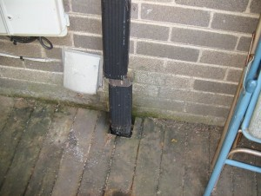
Downspouts
Condition: Needs Maintenance
Problems:
-The downspouts cause water to pool and run toward the house.
-There are spots where downspouts are missing resulting in deterioration to the house.
-There are downspouts missing from the building.
Comments:
Downspout does not divert water away from foundation properly. There are downspouts that need to be extended. Keep downspouts extended 5' - 6' from the building. Gutters and downspouts need to be added.
Eaves & Soffits
Condition: Needs Maintenance
Comments:
Some of the soffit vents appear to be blocked or covered. It is important to have adequate soffit vents for proper attic ventilation.
Columns
Condition: Satisfactory
Type: Steel
Comments:
Columns are located in basement to support spans.
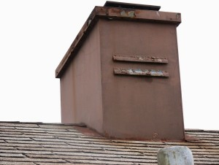
Chimney(s)
Condition: Needs Maintenance
Type: Metal
Location: East side
Comments:
Rusting was observed on chimney cap. Chimney flashing is improperly installed. You should consult a licensed contractor about the needed repairs.

Roofing Components

The inspection of the roof system includes a visual examination of the surface materials, connections, penetrations and roof drainage systems. We examine the roofing material for damage and deterioration. We examine the roof system for possible leaks, damage and conditions that suggest limited remaining service life. We may offer opinions concerning repair and/or replacement if warranted. Opinions stated herein concerning the roofing material are based on the general condition of the roof system as evidence by our visual inspection. These do not constitute a warranty that the roof is or will remain, free of leaks. All roofing systems require annual maintenance. Failure to perform routine maintenance will usually result in leaks and accelerated deterioration of the roof covering and flashings. When provided, our estimates of the roof's life expectancy are based on the assumption that the roof will be properly maintained during that period. The only way to determine whether a roof is absolutely watertight i s to observe it during a prolonged rainfall. Many times, this situation is not present during the inspection and we cannot confirm this condition. We suggest that an annual inspection of the Attic area be performed where accessible to identify if any leaks are evident.
Roof Style
Type: Gable
Viewed from: Ladder
Comments:
The roof was inspected from the top of a ladder. The view of some areas of the roof was obstructed by exhaust flues, vent pipes, and the roof structure and pitch.
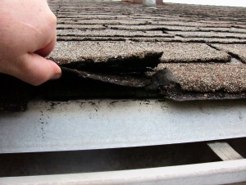
Roof Covering
Shingles: Asphalt
Layers: 3 Layers
Approximate Age: years
Condition: Professional Consultation
Problems:
-There are gaps between the shingles.
-There are more than 2 layers of shingles.
-The shingle tabs are clawing or curling up at the edges.
-The shingle tabs are loose and can be lifted.
-The shingles are brittle.
-There are sagging, uneven, or damaged sections of roof covering.
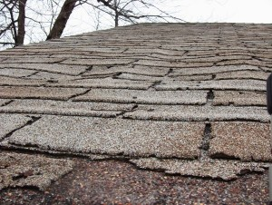
Roof Leaks
Leaks: Some
Viewed: Ladder
Problems:
-The roof has weather-worn flashing.
-There is discoloration, rot, mold, or mildew on the roof framing.
Comments:
There are some sunken areas where it is apparent that the shingles have failed and water is penetrating onto the sheathing. In such cases some of the sheathing may need to be replaced when the shingles are replaced. Further water damage could be occurring within the walls or ceilings as the result of water intrusion.
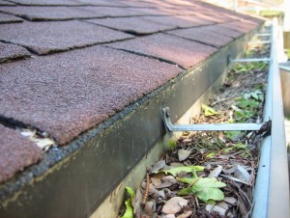
Gutters & Downspouts
Type: Aluminum
Condition: Needs Maintenance
Extensions: Has Extensions
Problems:
-The gutters are clogged with debris from overhanging trees.
-The gutter/downspout connections are bad.
-There are missing sections of gutters/downspouts.
Comments:
There are down spouts that need to be extended. Downspout does not divert water away from foundation properly. Damage or failure was observed.
Skylights
Condition: None
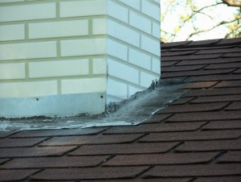
Exposed Flashing
Type: Aluminum, Rubber
Condition: Needs Maintenance
Problems:
-The flashing is not properly installed.
-There are vents flashed with roofing cement.
-There is evidence of seepage from flashed areas.
Comments:
Leaking observed at the chimney flue. Amateur patch job done with roof cement. Flashing at faux chimney cover is flush over shingles and needs replaced.

Plumbing Systems

Our Inspection of the plumbing system includes a visual examination of the exposed portions of the domestic water supply, drain waste, vent, gas lines, faucets, fixtures, valves, drains, traps, exposed pipes and fittings. These items are examined for proper function, excessive or unusual wear, leakage and general state of repair. The hidden nature of piping prevents inspection of every pipe and joint connection, especially in walls, floors and ceiling voids. A sewer lateral test is necessary to determine the condition of the underground sewer lines. This type of test is beyond the scope of this inspection. Our review of the plumbing system does not include landscape irrigation systems, water wells, on site and/or private water supply systems, off site community water supply systems, or private (septic) waste disposal systems unless specifically noted. A qualified specialist prior to the closing of escrow can perform review of these systems. Our inspection of the water heater includes a visual examination of the accessible portions of the tank, gas, electrical and/or water connections, venting and safety valves. These items are examined for proper function, excessive or unusual wear, leakage and general state of repair.
Water Service
Type: Public
Condition: Satisfactory
Comments:
Northeast utility closet in basement.
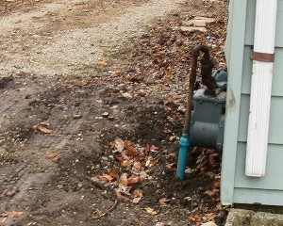
Fuel Service
Condition: Professional Consultation
Type: Gas Meter
Meter Location: (See problem list)
Shutoff Valve Location: East corner near drive
Comments:
This gas meter is located between the driveway and a path where vehicles can be driven or parked which presents a safety hazard. Recommend protecting this location against any impacts.
Water Entrance
Type: Copper
Size: 3/4
Comments:
The entrance is copper, but much of the house uses galvanized pipe which has a useful life span limited to around 20 years.
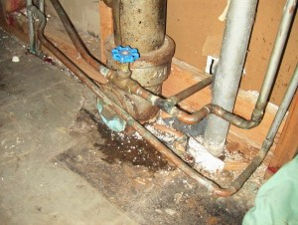
Waste
Condition: Needs Maintenance
Type: Public
Pipes: Plastic, Cast Iron
Comments:
Cast iron part of system appears to have a small amount of seepage at the joint as shown in the photo. Old cast iron pipes rust from the inside out and will eventually need to be be replaced.
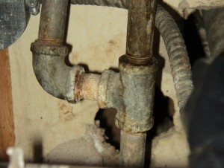
Fixtures
Condition: Needs Maintenance
Problems:
-There is corrosion on the pipes or valves.
Comments:
The pipes beneath the bathroom and kitchen sinks are galvanized steel. Corrosion and indications of slow leaks were detected. Galvanized steel rusts from the inside out which can inhibit water pressure. Suggest budgeting for upgraded plumbing.
Water Heater
Condition: Satisfactory
Fuel Type: Gas
Location: Kitchen utility room
Capacity: 60
Extension: Present
Relief Valve: Present
Seismic Restraint: Not Applicable
Gas Shutoff: Present
Venting (Air Supply): Not Present
Expansion Tank (Gas): Not Applicable
Pipes
Condition: Needs Maintenance
Material: Copper, Galvanized
Flow Rate: Satisfactory
Problems:
-The pipes are showing signs of deterioration.
-There are signs of leakages from the pipes.
-There are signs of seepage from the pipes.
-There are signs of rust/corrosion on the pipes.
Comments:
This house has partially updated plumbing, but still has galvanized pipes beneath the sinks. The amount of corrosion and slow seepage of water leaks indicates that the pipes are near the end of their useful life and will eventually need to be replaced. While the leaks were not severe, even a very slow leak can cause damage to the structure over time.
Drains
Condition: Satisfactory
Type: Plastic, Cast Iron
Vent Pipes
Condition: Satisfactory
Type: Plastic, Cast Iron

Electrical Systems & Components

Our examination of the electrical system includes a visual examination of the exposed and accessible branch circuits, wiring, service panel, over current protection devices, lighting fixtures, switches, and receptacles. Service equipment, proper grounding, wiring methods and bonding are focal points. We inspect for adverse conditions such as lack of grounding and bonding, over-fusing, exposed wiring, open-air wire splices, reverse polarity and defective GFCI's. The hidden nature of the electrical wiring prevents inspection of every length of wire or their connections. Telephone, video, cable, audio, security systems and other low voltage systems were not included in this inspection unless specifically noted. We recommend you have the seller or a specialist demonstrate the serviceability or locations of these systems to you if necessary. Any electrical repairs attempted by anyone other than a licensed electrician should be approached with caution. The power to the entire house should be turned off prior to beginning any repair efforts, no matter how trivial the repair may seem. Aluminum wiring requires periodic inspection and maintenance by a licensed electrician. Operation of time clock motors is not verified. Inoperative light fixtures often lack bulbs or have dead bulbs installed. Light bulbs are not changed during the inspection, due to time constraints. Smoke Alarms should be installed within 15 feet of all Bedroom doors and in Bedrooms. These units should be tested monthly.
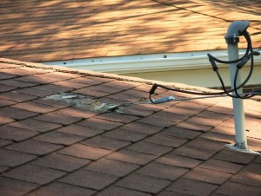
Service Entrance Cable
Capacity: 200 Amps
Location: Basement (north wall)
Volts: 240-120 Volts
Condition: Needs Maintenance
Problems:
-The service entrance cable is improperly anchored to the wall.
Comments:
It appears that the roof anchor for this overhead service has been pulling away from the sheathing and should be examined and possibly re-anchored by a professional.
Service Line Entrance
Type: Overhead
Condition: Satisfactory
Conductor: Copper
Main Disconnect Location: basement
Wiring: Conductors in Conduit
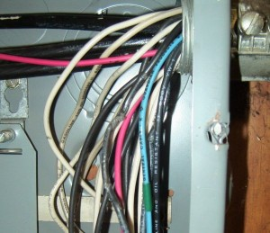
Main Panel
Condition: Professional Consultation
Volts: 240-120v
Capacity: 200A
Type of Overload Protection: Circuit Breakers
Bonding: Bonded
Grounding: Grounded
Location: Basement - street side
Problems:
-There is evidence of circuit breakers failing / overloading.
Comments:
One of the wires shown in the photo has melted insulation which could indicate an over-fused circuit. This could represent a fire hazard and should be examined by an licensed electrician.
Sub Panel
Condition: Satisfactory
Volts: 240-120v
Capacity: 60A
Location: Garage
Circuits & Conductors
Condition: Needs Maintenance
Type of Wiring: Romex
Outlets | Number | GFCI
Exterior | 2 | No
Garage | 3 | No
Kitchen | 2 | No
Bathroom | 2 | Yes
Comments:
Recommend GFCI's in all kitchens, garages, bathrooms, and exteriors.
Outlets, Fixtures, & Switches
Number Tested: Representative Number
Method of Testing: plug tester
Condition: Needs Maintenance
Outlet Testing:
Reverse Polarity: Yes
Non-GFCI: Yes
Ungrounded: Yes
Voltage Drop: No
Problems:
-There are missing or broken faceplates.
-There are rooms that do not have a light/outlet operated by a switch.
Comments:
No power was observed at the receptacle outlet. Electrical wiring is not properly protected. Outlet covers are broken. Reverse polarity of receptacle outlet was observed. Receptacle outlet covers are damaged. Receptacle outlet spacing appears to be inadequate.
Smoke Detectors
Condition: Not Satisfactory
Smoke Detectors: Not Tested
Problems:
-There are bedrooms without nearby smoke detectors.
Comments:
Smoke detectors are installed too far from bedrooms. Additional detectors are recommended. A smoke detector is required near bedrooms. Replace detector batteries every 6 months. It is recommended that smoke detectors are replaced every 10 years.

Attic

Our inspection of the Attic includes a visual examination of the roof framing, plumbing, electrical, and mechanical systems. There are often heating ducts, bathroom vent ducts, electrical wiring, chimneys and appliance vents in the Attic. We examined these systems and components for proper function, unusual wear and general state of repair, leakage, venting and unusual or improper improvements. When low clearances and deep insulation prohibits walking in an unfinished Attic, inspection will be from the access opening only. Vaulted ceilings cannot be inspected.
Attic Access
Access Type: Scuttle Hole
Attic Access Location: Bedroom closet (upper level)
Comments:
The inspector was able to view about 75 percent of the attic space from the top of a step ladder at the service hatch. No walk boards were provided. Complete attic views are obstructed by framing members, insulation, attic equipment, and stored items.
Attic Ventilation
Condition: Needs Maintenance
Type: Ridge Vents, Soffit Vents
Fan Type: None Observed
Problems:
-There is inadequate ventilation in the attic.
Comments:
Insulation is blocking eaves vents. Baffles are recommended for proper ventilation of the attic.
Roof Frame
Condition: Satisfactory
Type: Truss
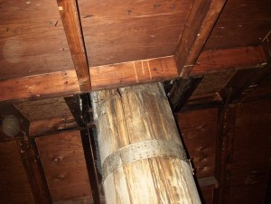
Vent Pipes & Flashing
Condition: Needs Maintenance
Leaks Observed: Visible Leaks
Problems:
-There are vents that leak or function improperly.
Comments:
As the photo shows, there are some leaks at flashing points where an exhaust flue goes through the roof. The stains on the flue are indications of this leak.
Ceiling Frame
Condition: Needs Maintenance
Type of Framing: Joist Framing
Problems:
-There is moisture damage to the ceiling frame.
Comments:
The roof leak has caused some limited damage to the ceiling frame.
Moisture & Mildew
Condition: Needs Maintenance
Type: Some Condensation, Mold and Mildew
Comments:
Darkened areas where water is penetrating roof surface at failed shingles (see Roof Covering notes).
Attic Insulation
Condition: Needs Maintenance
Type: Poured
Location: In Floor
Average Depth (Inches): 4
Comments:
Insulation has no vapor barrier. We recommend upgrading attic insulation.
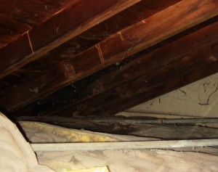
Attic Sheathing
Observed: Observed
Condition: Needs Maintenance
Problems:
-There are signs of leakages on the sheathing.
-There are signs of water damage to the sheathing.
Comments:
Dark areas indicative of water penetration on SE area of sheathing below area of suspected shingle failure. There were minimal shiners (nails through the sheathing that missed the roof truss framing.)

Interior Components

Our inspection of the Interior includes a visual inspection of the readily accessible portions of the walls, ceilings, floors, doors, cabinetry, countertops, steps, stairways, balconies and railings. Please note that a representative sample of the accessible windows and electrical receptacles are inspected. These features are examined for proper function, excessive wear and general state of repair. In some cases, all or portions of these components may not be visible because of furnishings and personal items. In these cases some of the items may not be inspected. The condition of walls behind wall coverings, paneling and furnishings cannot be judged. Only the general condition of visible portions of floors is included in this inspection. As a general rule, cosmetic deficiencies are considered normal wear and tear and are not reported. Determining the source of odors or like conditions is not a part of this inspection. Floor covering damage or stains may be hidden by furniture. The condition of underlying floor coverings is not inspected. Determining the condition of insulated glass windows is not always possible due to temperature, weather and lighting conditions. Check with owners for further information. All fireplaces should be cleaned and inspected on a regular basis to make sure that no cracks have developed. Large fires in the firebox can overheat the firebox and flue liners, sometimes resulting in internal damage.
General Information
Number of Bathrooms: 2
Number of Bedrooms: 4
Floors
Condition: Satisfactory
Type of floor: Carpet
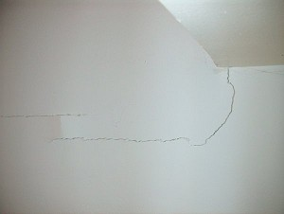
Walls
Condition: Needs Maintenance
Type: Drywall
Problems:
-There are cracks/holes in the wall.
Comments:
The photo illustrates a crack in the kitchen wall near the ceiling which could indicate uneven settlement in one area of the house.
Stairs / Railings  Condition: Needs Maintenance  Comments:  The handrail is loose. The handrail bracket is loose. This can constitute a safety hazard. | Ceilings  Condition: Satisfactory  Type: Drywall

Entry Doors  Condition: Satisfactory  Material: Wood  Insulation:  Other Entry Doors  Condition: Satisfactory  Type of Door: Sliding Glass  Insulation: Insulated  Interior Doors (door # 1)  Location: Dining room, Closets, Main Level  Condition: Satisfactory  Comments:  This component is functioning properly. | Interior Doors (door # 2)  Location: Upstairs bedrooms  Condition: Satisfactory  Interior Doors (door # 3)  Location: All Bathroom Doors  Condition: Satisfactory  Interior Doors (door # 4)  Location: Lower level Den  Condition: Needs Maintenance  Comments:  This door does not close properly and may be out of square..

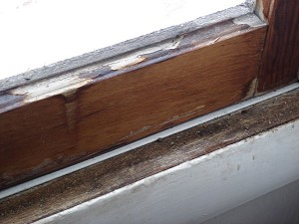
Windows
Condition: Needs Maintenance
Type: Double Hung
Material: Wood
Glass:
Storm Windows: Yes
Problems:
-The windows insulate poorly.
-There are windows stuck or painted shut.
-There are bedrooms without properly functioning egress windows.
Comments:
Some window sashes do not operate properly. Window weather stripping is damaged or defective. Fire egress for the window is inadequate in NE bedroom.
Moisture and Mildew
Condition: Satisfactory
Degree of Damage: None
Fireplace
Condition: Needs Maintenance
Type: Masonry
Operational: Yes
Problems:
-The chimney needs cleaning.
Comments:
The flue is in apparent need of cleaning. Combustibles are too close to the fireplace opening.
Bedroom 1
Condition: Needs Maintenance
Comments:
This northeast bedroom does not have an operable window. Legal bedrooms must have a method of egress.
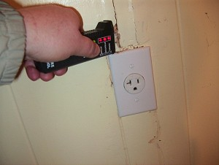
Laundry Room
Condition: Needs Maintenance
Comments:
Photo shows the wall next to 240-volt outlet testing high for moisture. It appears that a roof leak is draining down the wall in the laundry room.
Den/Home Office
Condition: Needs Maintenance
Problems:
This room appears to have been converted from a garage.
Comments:
When rooms have been added or converted on a home, there could be problems with adequate ventilation and conditioned air. Furthermore, converted spaces may lack adequate power receptacles and insulation.

Bathroom 1

Our inspection of the bathrooms included a visual examination of the readily accessible portions of the floors, walls, ceilings, cabinets, countertops and plumbing fixtures. Bathrooms are inspected for water drainage, damage, deterioration to floor and walls, proper function of components, active leakage, unusual wear and general state of repair. Bathroom fixtures are run simultaneously to check for adequate water flow and pressure. Fixtures are tested using normal operating controls. Vent fans and their ductwork are tested for their proper operation and examined where visible. Shower pans are visually checked for leakage, but leaks often do not show except when the shower is in actual use. Determining whether shower pans, tub/shower surrounds are watertight is beyond the scope of this inspection. It is very important to maintain all grout and caulking in the bath areas. Very minor imperfections can allow water to get into the wall or floor areas and cause damage. Proper ongoing maintenance will be require ed in the future.
Bathroom Location
Location: downstairs
Toilets
Condition: Satisfactory
Ventilation
Condition: Satisfactory
Fan Vents To: Outside
Floor
Condition: Satisfactory
Type: Vinyl (Linoleum)
Problems:
-The edges of the floor (tiles) are lifting.
-The floor is not sealed properly.
Shower Walls
Condition: Satisfactory
Type: Fiber Glass
Floor
Condition: Satisfactory
Type: Vinyl (Linoleum)
Problems:
-The edges of the floor (tiles) are lifting.
-The floor is not sealed properly.
Receptacles
Condition: Satisfactory
Type: GFCI
Moisture & Mildew
Condition: Needs Maintenance
Type: Mold and Mildew
Sinks
Condition: Needs Maintenance
Problems:
-There is corrosion on the pipes or valves.
-There are signs of leakages in the fixtures.
Comments:
Water pressure appears low at this fixture. Corroded galvanized pipe beneath sink appears to be seeping and rust build-up inside the pipe could be occurring.

Bathroom 2

Bathroom Location
Location: upstairs
Toilets
Condition: Satisfactory
Ventilation
Condition: Satisfactory
Fan Vents To: Outside
Bathtub
Condition: Satisfactory
Type: Built-In
Problems:
-The seal is caulked improperly.
Comments:
Rehabilitation of caulking is needed. This component is in need of minor repair.
Shower Walls
Condition:
Type: Fiber Glass
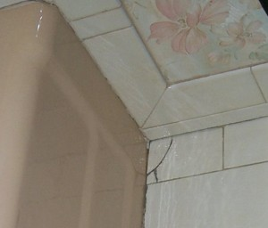
Floor
Condition: Needs Maintenance
Type: Ceramic Tile
Comments:
Tile is cracked near tub and needs re-grouted. Flexible caulking needs applied wherever tile meets an edge.
Receptacles
Condition: Satisfactory
Type: GFCI
Moisture & Mildew
Condition: Satisfactory
Type: None
Sinks
Condition: Satisfactory

Kitchen

Inspection of standalone refrigerators, freezers and built-in icemakers are outside the scope of the inspection. No opinion is offered as to the adequacy of dishwasher operation. Ovens, self or continuous cleaning operations, cooking functions, clocks, timing devices, lights and thermostat accuracy are not tested during this inspection. Appliances are not moved during the inspection to inspect below or behind them. Portable dishwashers are not inspected, as they require connection to facilitate testing and are sometimes not left with the home.
Cabinets  Condition: Satisfactory  Counters  Condition: Satisfactory  Counter Tops:  Sink  Condition: Satisfactory  Problems:  -The caulking is deteriorating.  Flooring  Condition: Satisfactory  Type:  Receptacles  Condition: Satisfactory  Type: Non-GFCI  Comments:  Recommend upgrading to GFCI for all counter top outlets near sink.  Moisture and Mildew  Condition: Satisfactory  Degree of Damage: None  Ventilation  Condition: Satisfactory  Fan Vents To: Exterior | Range/Oven  Condition: Satisfactory  Fuel Type: Gas  Operational: Operating  Make: GE  Model: Unknown  Refrigerator  Condition: Satisfactory  Operational: Operating  Make: GE  Model: RS2000  Dishwasher  Condition: Satisfactory  Operational: Operating  Make: GE  Model: Unknown  Microwave  Condition: Satisfactory  Operational: Operating  Make: Sharp  Model: Unknown  Disposal  Condition: Satisfactory  Operational: Operating  Make: Unknown  Model: Unknown  Trash Compactor  Not applicable

Basement / Crawlspace

Many of the building's structural elements and portions of its mechanical systems are visible inside the Crawlspace. These include the foundation, portions of the structural framing, distribution systems for electricity, plumbing, and heating. Each accessible and visible component and system was examined for proper function, excessive wear or abnormal deterioration and general state of repair. It is not unusual to find occasional moisture and dampness in the Crawl Spaces and we advise annual inspections of this area. Significant or frequent water accumulation can affect the structures foundation and support system and would indicate the need for further evaluation by professional drainage contractor. We advise to monitor your Crawlspace during the rainy season.
Description
Type: Partial, Crawlspace
Access Location: Stairs
Comments:
Basement is unfinished space with a connected crawlspace under the east side of the house.
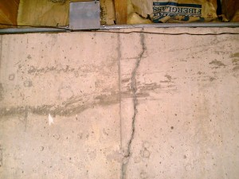
Foundation
Condition: Satisfactory
Type: Concrete
Comments:
Not all areas of the foundation were visible at the time of the inspection. The foundation appears to be performing from what can be observed. There are several thin cracks visible in the foundation less than a quarter inch wide which are typical of an older masonry foundation.
Columns
Condition: Satisfactory
Type: Steel
Stairs
Condition: Satisfactory
Floor
Condition: Satisfactory
Floor Type: Concrete, Dirt
Comments:
Partial basement has a concrete floor. Floor of the crawlspace is gravel-covered dirt.
Walls
Condition: Satisfactory
Wall Type: Open
Floor Drain
Condition: Satisfactory
Visibility: Not Visible
Sump Pump
Condition: Satisfactory
Type: Submersible
Status: Not Tested
Ceiling
Condition: Satisfactory
Ceiling Type: Open
Insulation
Condition: Satisfactory
Location: Perimeter walls of crawlspace
Vapor Barrier (Uninsulated Crawl Space)
Condition: Needs Maintenance
Visibility: Visible
Comments:
The basement contains an additional gravel-covered crawlspace that needs to be covered completely by a vapor barrier. A vapor barrier is a sheet of plastic that prevents moisture from the ground from rising into the structure.
Floor Joists
Condition: Satisfactory
Type: Conventional
Visibility: Visible
Sub Flooring
Condition: Satisfactory
Visibility: Visible
Dampness
Condition: Satisfactory
Degree of Damage: None
Comments:
Very minimal musty smell and dampness observed.
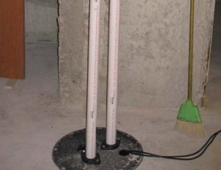
Sewage Ejector
Condition: Needs Maintenance
Tested: Not Tested
Problems:
-The sewage ejector pump does not appear to be functioning properly.
Comments:
The sewage ejector pump was unplugged and may not function properly. The sewage ejector pump moves waste from basement plumbing fixtures (i.e. toilets, showers, etc) to the level of the sewer line

Heating System

Our examination of the heating system includes a visual examination of the exposed and accessible heating equipment, thermostat, safety controls, venting and the means of air distribution. Our inspection of the heating system includes activating the heating system via the thermostat and a visual examination of the accessible components listed below. These items are examined for proper function, excessive or unusual wear and general state of repair. Heat exchangers are inaccessible by design, and are not part of the ASHI standards of practice. They must be completely removed from the furnace to be fully evaluated. Our inspection does not include disassembly of the furnace. The inspector cannot light pilot lights due to the liability. The inspector does not test safety devices. To obtain maximum efficiency and reliability from your heating system, we recommend annual servicing and inspections by a qualified heating specialist. Determining the condition of oil tanks, whether exposed or buried, is beyond the scope of this inspection. Leaking oil tanks represent an environmental hazard, which is sometimes a costly condition to address.
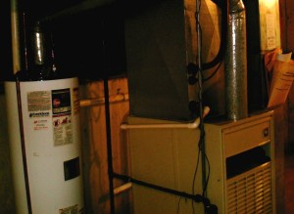
Heating System
Condition: Satisfactory
Type: Forced Air
Fuel: Natural Gas
Age: unknown years
Capacity: 100,000 BTU's
Heat System Location: basement
Thermostat Location: first floor
Comments:
Furnace is over 20 years old and only 70 percent efficient. It is nearing the end of its useful life. Consider budgeting for a high efficiency furnace.
Fuel Source
Condition: Satisfactory
Fuel Type: Natural Gas
Fuel Supply: Public Gas
Status: Turned On
Heat Exchanger
Condition:
Status: Not Tested
Visibility: Not Visible
Heat Distribution
Condition: Satisfactory
Type: Ductwork
Pipes: Galvanized
Located in: Each Room
Unit Venting
Condition: Needs Maintenance
Problems:
-The heating system draws in air from inside the house.
Comments:
Suggest updating furnace to draw supply air from outside the house.
Humidifier
Condition: Untested
Air Filters
Condition: Satisfactory
Filter Type: Disposable
Gas Furnace
Condition: Satisfactory
Comments:
Lennox MGF/3-100A Serial Number = 4365L37831 70 AFUE 100,000 BTU/h

Cooling System

This is a visual inspection limited in scope by (but not restricted to) the following conditions: - Window and/or wall mounted air conditioning units are not inspected. - The cooling supply adequacy or distribution balance are not inspected. - Pressure tests on coolant systems are not within the scope of this inspection; therefore no representation is made regarding coolant charge or line integrity. - Judgment of system efficiency or capacity is not within the scope of this inspection. - Cooling systems are not dismantled in any way. Secured access covers are not removed. - The interior components of evaporators, condensers and heat pumps are not viewed. - The interior conditions of cooling components are not evaluated. - The presence of leaking refrigerant lines, heat pump oil, etc., is outside the scope of this inspection. Please also refer to the pre-inspection contract for a detailed explanation of the scope of this inspection.
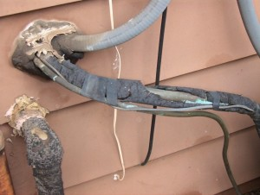
Air Conditioning Unit
Condition: Needs Maintenance
Status: Tested
Age: estimate 5-10 years
Capacity: 4 ton
Location: South side (condenser)
Last Service Date: unknown
Problems:
-There are obstructions blocking a free air exchange.
-The refrigerant tubes are poorly insulated.
Comments:
Model GE LMB-48AK10 (4-tons). The unit appears the right size for a 2,000 sq. ft. home and produces cold air when tested. The insulation on the return line is missing, damaged, or defective decreasing efficiency. Clean leaves and debris away from outdoor condenser coil.
Air Conditioning Type
Condition: Satisfactory
Type: Central Air
Fuel: Turned On
Comments:
Air handler in basement appears to be in serviceable condition without air leaks in unit housing. Indoor evaporator coil and drain pan appear to function properly.
Electrical Disconnect
Condition: Satisfactory
Location: south side of house
Air Distribution
Condition: Satisfactory
Type: Ductwork
Located in: Each Room
Comments:
Duct type is rigid metal.

Garage / Carport

The Garage is inspected as best as possible, but can be limited due to parked cars or personal stored items. Due to this area be cluttered or areas being inaccessible, it is common for sections that cannot not be fully inspected or items identified during our limited inspection. We suggest that a walk-through be performed once the home is vacant. If this is a new construction inspection or vacant home this area will be inspected thoroughly. Determining the heat resistance rating of firewalls and doors is beyond the scope of this inspection. Flammable materials should not be stored within the Garage area if possible.
Garage Description
Condition: Satisfactory
Type: Attached Garage
Comments:
2-car.
Vehicle Doors
Condition: Satisfactory
Status: Tested
Comments:
This component is functioning properly.
Flooring
Condition: Satisfactory
Floor Type: Concrete
Walls/Windows/Ceiling
Condition: Satisfactory
Separation Wall (Attached Garage)
Condition: Needs Maintenance
Type: 5/8" Drywall
Problems:
-There are holes or gaps in common drywall.
Comments:
Repair all breaches in common drywall. Floor penetrations are not properly fire stopped. Ceiling penetrations are not properly fire stopped.
Door to Living Space (Attached Garage)
Condition: Satisfactory
Door Type: Solid Wood
Fire Door Properties: Fire Resistant
Ventilation System
Condition:
Status: Not Applicable
Moisture & Mildew
Condition: Satisfactory
Type: None
Comments:
Receptacles
Condition: Needs Maintenance
Type: Non-GFCI
Problems:
-There are Non-GFCI receptacles in the garage.
Comments:
Suggest upgrading to ground fault circuit interrupter receptacles.
Door Opener
Condition: Satisfactory
Comments:
This component is functioning properly.

